User Login

Document Information

|  |  |
| --- | --- |
| **Document Title** | UC-1 User Login |
| **Document Owner** |  |
| **Version** |  |
| **Status** |  |
| **Date** |  |

1. Brief Description

This use case describes the process of a user logging into the SLOS system.

1. Actors

* Parent
* Student
* School Administrator
* Food Service Staff

1. Trigger

User selects the "Login" button on the SLOS system's homepage.

1. Pre-Conditions

* The user has access to a device with an internet connection.
* The user have a valid school ID number and secret key provided by the school.

1. Post-Conditions

* User is logged into the system and granted access to their respective profile and features.

1. Basic Flow
2. User navigates to the SLOS system's homepage.
3. ~~User clicks the "LogIn" button.~~
4. System displays the login form.
5. User fills out the required registration fields, which include: school ID number, secret key school provided.
6. User clicks the “LogIn” button to submit the registration form.
7. System verifies that the ID number provided and the secret key are correct.
8. System logs in the user, grants access to their respective profile and features.
9. System redirects user to homepage.
10. Alternate Flows
11. Exception Flows

* 6a: If the system verifys that the ID number or the secret key provided are not correct, the system displays an error message and prompts the user to try again.

1. Business Rules

* The school ID number and secret key provided must match the information stored in the system.

1. Non-Functional Requirements

* The secret key must be hash in MD5.

1. Supplemental Requirements
2. Visual Model

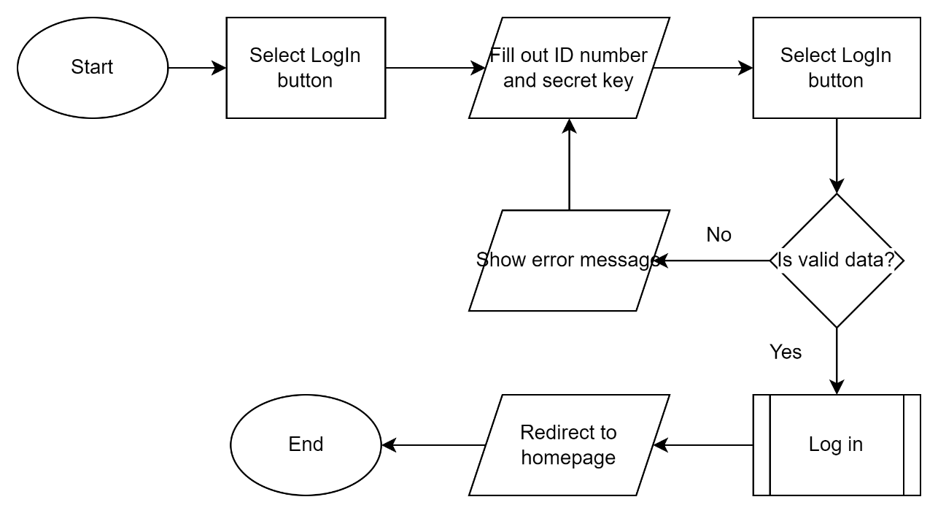

Revision History

|  |  |  |  |  |
| --- | --- | --- | --- | --- |
| V. | Date | Author | Description | Status |
| 1.1 | 01/05/2023 | Hoang Anh | Remove basic flow 2, because when accessing the SLOS homepage with out logged in, the system redirects the user to a LogIn form. |  |
|  |  |  |  |  |